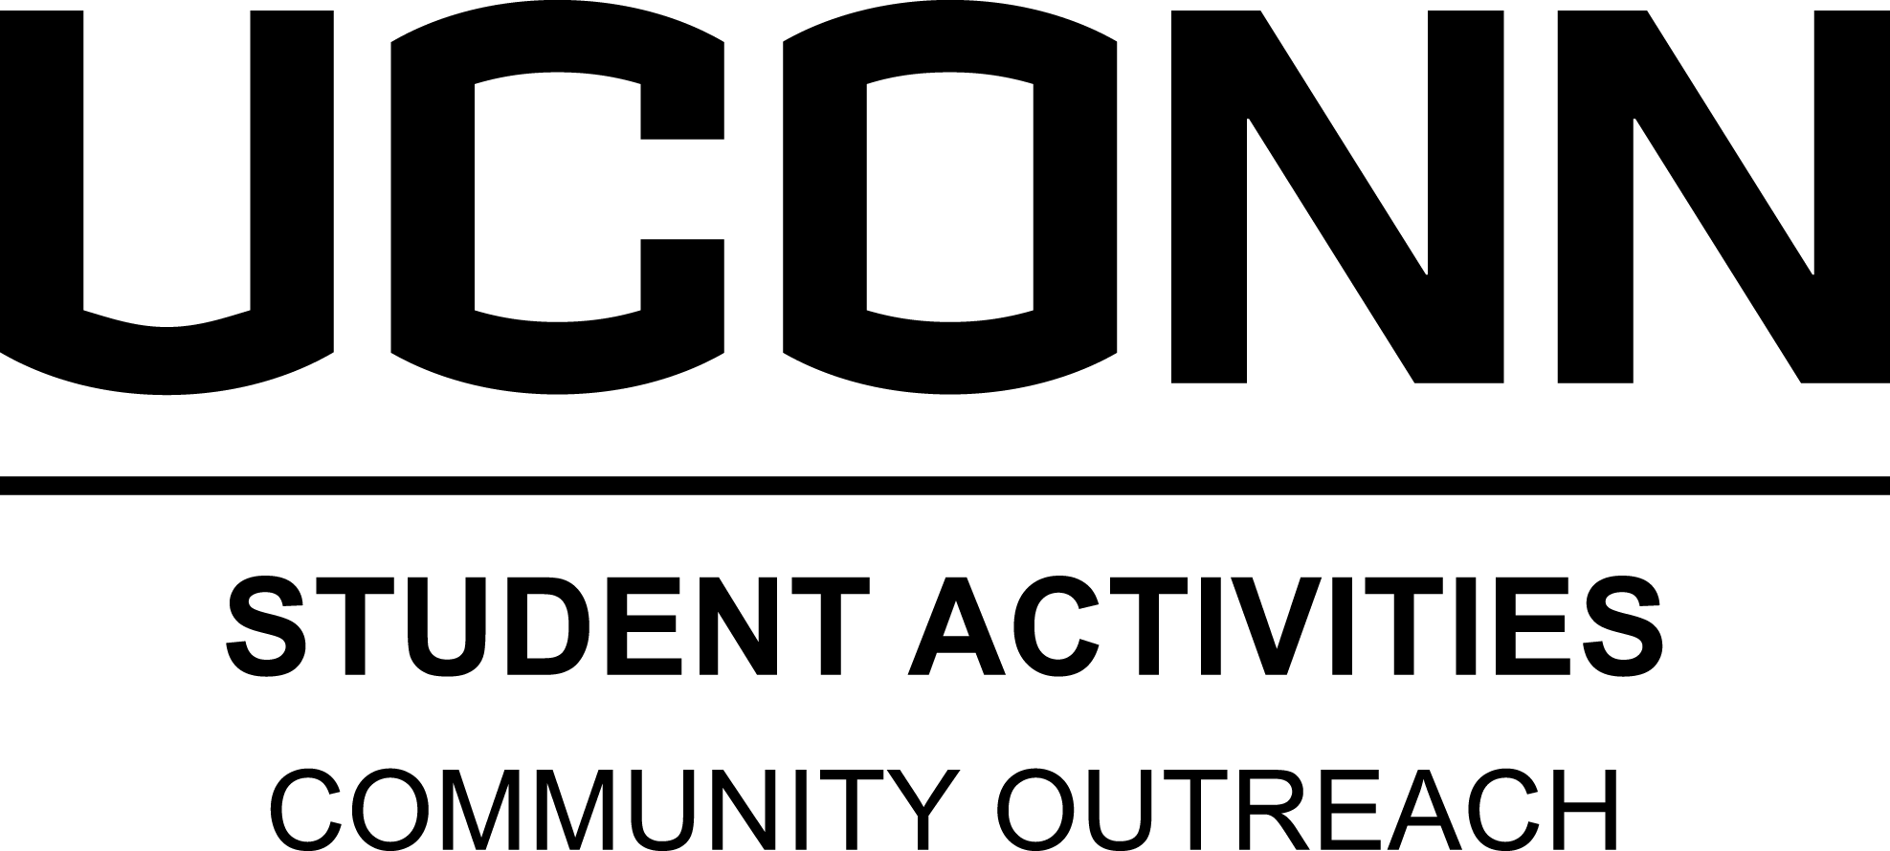
Special Olympics Committee
Program Director
Position Description

Position Summary

Special Olympics (SO) is an international nonprofit organization dedicated to providing year-round sports training and athletic competition for children and adults with intellectual disabilities. Community Outreach (CO) supports SO through ongoing volunteer opportunities with a primary focus put towards the Annual 3v3 Basketball Tournament (fall semester), Smile Mile, and the Husky Soccer Tournament (spring semester). Director will assist Fall and Spring sports coaching and programs and other SO service opportunities as needed. The Program Director will also oversee the other SO Project Managers. Specific tasks and obligations for each program vary depending on the program; however, the following responsibilities are required of all program directors.

Major Duties and Responsibilities

- Program Management and Development
  - Develop appropriate goals
  - Regularly evaluate program and cultivate means to enhance its effectiveness
  - Communicate and meet regularly with Student Coordinator and designated CO staff member
  - Support project managers as needed, including coordinating the scheduling of events and reservations of materials, locations, and transportation needs of the specific event
  - Participate as a committee member for at least one SO related project or event

- Volunteer Management
  - Provide ongoing monitoring and supervision of the project managers
  - Identify and create training and support materials that facilitate development of the skills necessary for project managers to achieve their objectives
  - Facilitate meetings, trainings and social events for committee members
- Communicate and meet regularly with the Special Olympics representative, the Social Services Coordinator and the CO staff
  - Communicate and meet regularly with designated CO staff member

- Administrative Tasks
- Attend all related CO meetings, trainings, seminars, and workshops
- Manage any financial or other resources including budgeting, purchasing, and tracking
- Collect and update data related to programs, membership, and service hours
- Schedule and monitor transportation
- Represent CO at University classes, meetings, or events
- Perform other related duties and activities to support the program and the Office of Community Outreach, as needed

- Program Participation
- Program directors are expected to participate in their program on a regular schedule as decided with staff supervisor

Qualifications

- Minimum Qualifications:
  - Strong interest in and commitment to community service
  - At least one semester related experience working with Special Olympics or on community service projects
  - Capacity to facilitate individual and group supervisory meetings including conflict resolution / problem solving
  - Capability to positively represent CO to the University and external community
  - Proficient interpersonal, relationship, and partnership building skills
  - Ability to effectively convey oral and written communication
  - Demonstrated program development and organizational skills including ability to manage multiple tasks/projects and planning special events
  - Ability to work independently, assess programmatic needs, and develop creative solutions
  - A strong appreciation for, as well as a willingness to work with and support, demographically diverse and traditionally underrepresented and oppressed groups (e.g. race, cultural, gender, ability, and sexual orientation)
  - Demonstrated basic knowledge and skill in the use of personal computers and basic software programs such as Microsoft Office Word and Excel
  - Willingness to work irregular and flexible hours including evenings and weekends
  - Student must not be on academic probation and maintain academic standing in accordance with the Department of Student Activities Student Leader Eligibility Policy (less than a 1.8 semester GPA for 1-23 credits, or less than a 2.0 semester GPA for 24+ credits)

- Preferred Qualifications:
  - One or more years experience working with related programs or activities, specifically the Special Olympics
  - One or more years related experience in a leadership and/or supervisory position
  - Demonstrated experience organizing and facilitating training workshops and public presentations
  - Excellent computer skills with an emphasis on Microsoft Office Word and Excel

Commitment

- Full academic year commitment is required
- Participation in CO training in August the week before Fall Semester begins
- 10-12 hours per week with some designated office hours; exact hours and schedule will fluctuate and are flexible to student’s academic schedule

The University of Connecticut is an Equal Opportunity Employer and supports all state and federal laws that promote equal opportunity and prohibit discrimination. In keeping with our commitment to build a culturally diverse community, the University of Connecticut encourages applications from women, veterans, people with disabilities and members of traditionally underrepresented populations.

